Clinic Management System

241001653 | Menna Ahmed Saad
241001799 | Menna Kamel Ali

INSTRACTOR: DR/ Muhammed Elsayeh

Introduction

The Clinic Management System is made to help clinics work better. It keeps track of things like departments and clinics and doctors and patients and appointments. The Clinic Management System stores all this information about doctors and patients and appointments.
The Clinic Management System is useful, for scheduling appointments. Keeping patient records and doctor information all in one place using a special kind of database called a relational database system. The Clinic Management System makes it easy to manage the clinic.

2. Problem Description
The project is about creating a database system for managing clinics. This system will help with things like scheduling appointments. It will also store information about patients. The clinic management system will manage doctors and the different departments. It will even track the details of appointments like what the patient's diagnosed with the status of the appointment and how much it costs. The clinic management system is really, about making things easier to manage at the clinic.

3. Entities and Attributes
Department
Dept_ID
Dept_Name

Clinic
Clinic_ID
Clinic_Name
Address
Dept_ID

Doctor
Doctor_ID
Doctor_Name
Phone_Number
Address
Specialization
Dept_ID

Patient
Patient_ID
Patient_Name
Phone_Number
Address
Birth_Date
Job

Appointment
Appointment_ID
Appointment_Date
Start_Time
End_Time
Cost
Status
Diagnosis
Patient_ID
Doctor_ID

4. ER Diagram
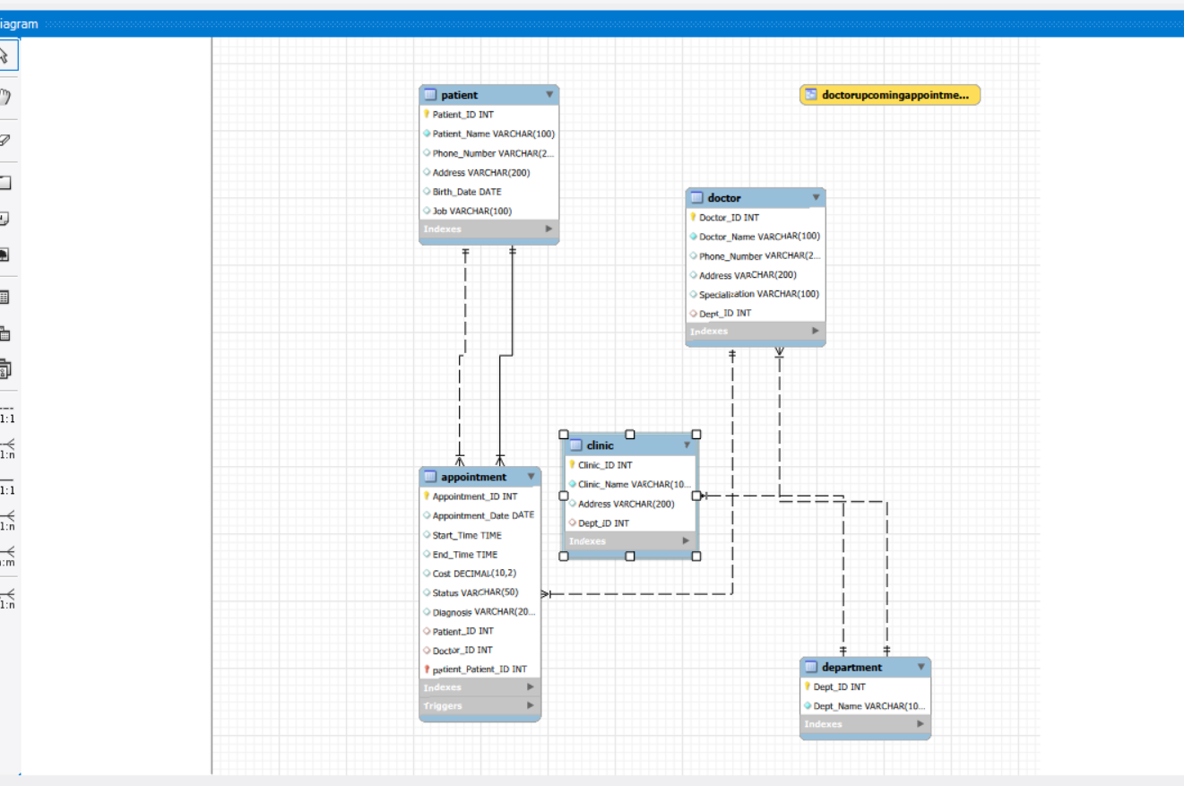

5. Relationships
A Department can have multiple Clinics (1:M relationship).
A Department can have multiple Doctors (1:M relationship).

A Clinic belongs to one Department (M:1 relationship).

A Doctor belongs to one Department (M:1 relationship).
A Doctor can have multiple Appointments (1:M relationship).

A Patient can have multiple Appointments (1:M relationship).

- Each Appointment is associated with one Doctor and one Patient (M:1 relationship).

6. SQL Implementation
The system was made using MySQL. This is what it does:
It creates tables
It puts data into these tables
It has views
It has triggers
It has queries
The system uses MySQL for all of this. It has a lot of features like tables creation and data insertion and views and triggers and queries, in MySQL.

GitHub Repository

https://github.com/m09927355-spec/Clinic-Management-System

7. conclusion
The Clinic Management System does a job of managing the clinic. It takes care of all the clinic operations. This includes the doctors, the patients and the appointments. The Clinic Management System uses a database system to do all of this. The Clinic Management System makes sure everything runs smoothly at the clinic from the doctors, to the patients and the appointments.

